Threads, Executors, Runnables, Android Handlers

THREAD
concurrent unit of execution, can help speed up performance, allows you to do multiple tasks at once
EX. Loading a video while watching a video

Each thread has its own program counter and stack

Every thread needs a runnable

RUNNABLES
Tasks that need to be done
uses a method called run

ANDROID HANDLERS
-allows you to send and process messages and runnable objects associated with a thread
two main uses-
schedule runnables and messages to be executed at the same time in the future, or to put a action in a queue a action to be executed in a different thread
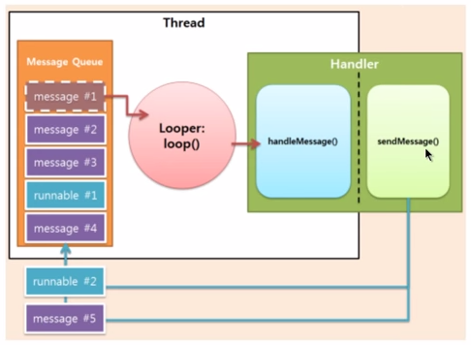

EXECUTOR
-A way to launch new tasks one at a time
-one method called execute
-use them to create thread pools automatically

key classes of executor service

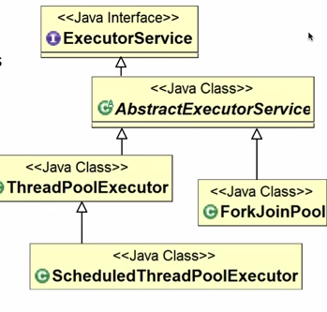

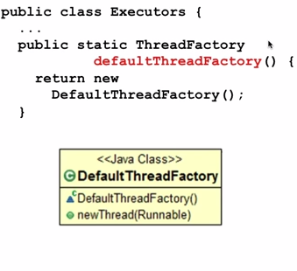

SOURCES
http://developer.android.com/reference/java/lang/Thread.html
https://www.youtube.com/watch?v=B25Nx48JuVo
https://www.youtube.com/watch?v=hbAEzuthPHE
http://developer.android.com/reference/java/util/concurrent/Executor.html
https://www.youtube.com/watch?v=2NAlvSkK9-k

